Ideation Phase
Empathize & Discover

Date | 19 February 2026
Team ID | LTVIP2026TMIDS77295
Project Name | Smart Sorting: Transfer Learning for Identifying Rotten Fruits and Vegetables

Empathy Map Canvas:Smart Sorting: Transfer Learning for Identifying Rotten Fruits and Vegetables.
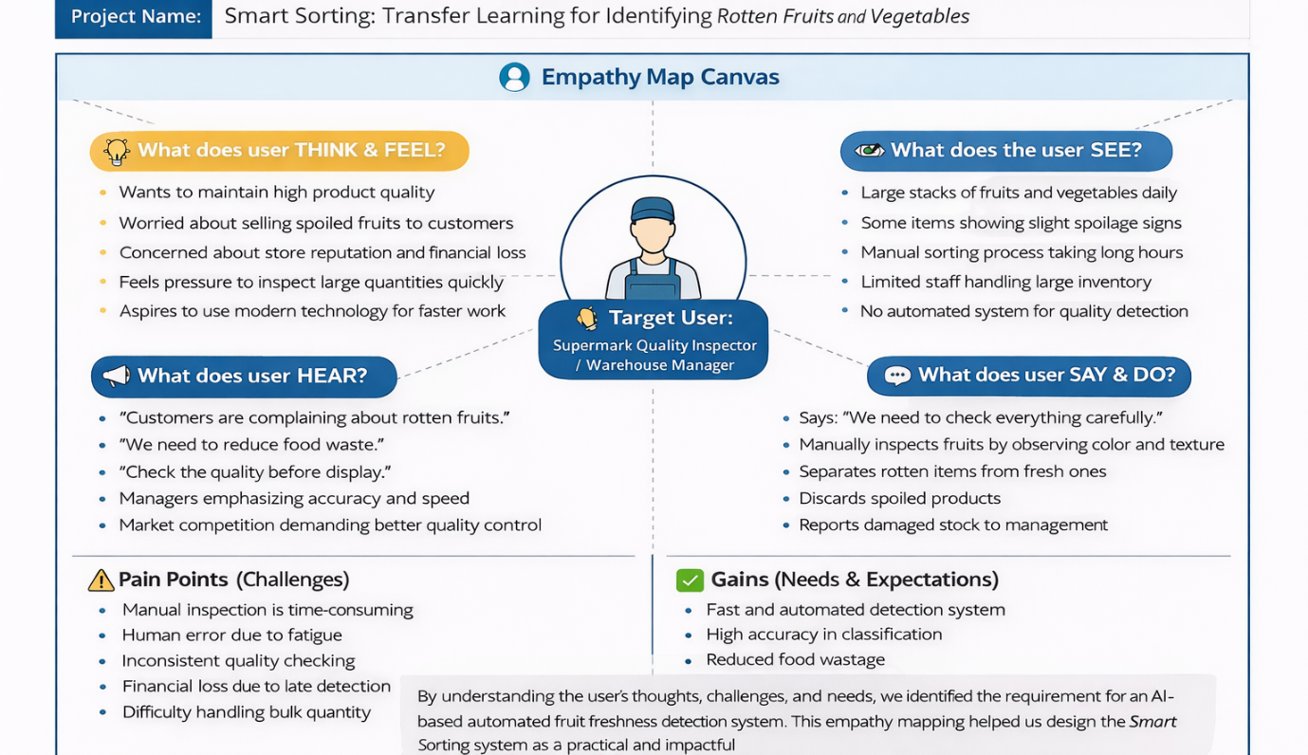
Conclusion
By understanding the user’s thoughts, challenges, and needs, we identified the requirement for an AI-based automated fruit freshness detection system.

